Newsletter Item 9
Aim: To provide families with information about bystander roles and responsibilities

Talking with your children about bystanders
Bullying involves more than the students who are bullied and those who bully others. Bullying often continues because people who are involved do not talk about it and seek help. This includes people who observe bullying – the bystanders. A bystander is someone who sees the bullying or knows that it is happening to someone else.

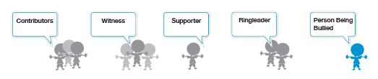
Bullying Situation Chart

Bystanders might be afraid that they will be bullied next, and this may influence their decision about what they will do if they see bullying happening. There are different types of bystanders and in this model, they are described as:
Contributors – This group offer support to the person bullying, either by helping the person to bully the other person or by encouraging the person bullying. This group might gather to watch the incident (sometimes from concern for the person being bullied, sometimes to see what will happen, and sometimes for enjoyment).
Supporters – This group dislikes the bullying, is concerned for the person being bullied and actively tries to help the person being bullied.

What can bystanders do?
If students see another student being bullied they should:
• Ask a teacher or support person for help
• Let the person doing the bullying know that what they are doing is bullying
• Refuse to join in with the bullying and walk away
• Support the student who is being bullied
• Support their friends and protect them from bullying (children who are alone are more likely to be the target of bullying, so encourage your children to be aware of children who are left out or on their own in the schoolyard).

