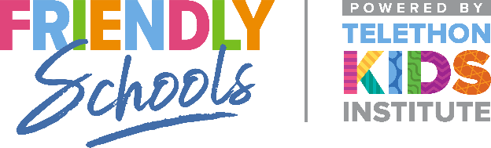

Newsletter Item 8
Aim: To provide practical strategies families can use to discourage their children from bullying others

Talking with your children if they are bullying others
All children are capable of bullying and it is important for you to respond in a calm and helpful manner if your child is displaying bullying behaviours. These strategies also apply if you believe your child may be bullying others online.

Encouraging your children not to bully others
You can:
• Talk with your children about what is acceptable behaviour and what is not, e.g. “we should not send nasty messages to people to make them feel bad”.
• Work together with your family to establish simple rules and expectations about how your family treat each other.
• Work with your family to establish clear guidelines about internet use at home.
• Encourage and provide opportunities for your children to openly discuss bullying issues, including cyberbullying with the family.
• Discuss friendship and help your children to make friends by encouraging them to play with other children at school, at home or in the neighbourhood.
• Discuss with your children how to be a friend online.
• Invite other children to your home for visits and teach your children how to make their guests feel welcome.
• Encourage your children to share and be aware of the feelings of others.

