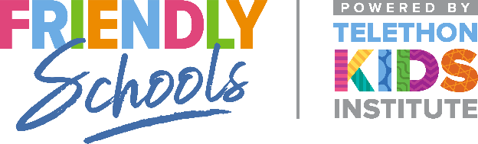

Newsletter Item 5
Aim: To provide families with strategies they can use to help their children if they are being bullied

What can I do if I think my children are being bullied at school?
• Try to talk with your children about what is going on.
• Listen to their concerns and believe them.
• Be aware of your own response and react in a calm and helpful manner.
• Talk with your children’s teachers and calmly discuss the situation and some possible strategies.
• Encourage your children to ask for help at school if they are being bullied e.g. talk about who they could talk to at school, and how to ask for help.

What can I do to help my children if they are being cyber bullied?
To prevent and respond to cyber-bullying, a useful acronym to remember is I-CURRB.
• Investigate what your child is doing online.
• Communicate regularly with your children to understand what they enjoy doing online.
• Use family safety software to keep track of what your children are able to access online.
• Research your school and Internet Service Provider’s (ISP) policies on cyberbullying. Different social media apps will also have their own policies.
• Report cyberbullying to your child’s school and/or ISP. If you have serious concerns for your child’s safety, contact your local police.
• Block communications from students who cyberbully others. Most social media apps allow you to block messages from identified people.

