Newsletter Item 3
Aim: To provide families with a definition of bullying

What is bullying?

Bullying is when one or more of the following things happen repeatedly to someone who finds it hard to stop it from happening.

Bullying is when a person or a group of people offline or online (mobile phone or Internet):
• Make fun of / tease someone in a mean and hurtful way
• Tell lies or spread nasty rumours about someone to try to make others not like him/her
• Leave someone out on purpose or not allow him/her to join in
• Hit, kick or push someone around
• Deliberately damage, destroy or steal someone’s things
• Threaten or make someone feel afraid of getting hurt
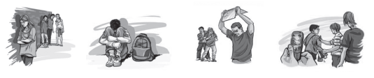

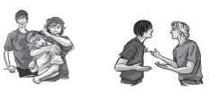
It is NOT bullying when:
• Teasing is done in a friendly, playful way.
• Two people who are as strong as each other argue or fight.

