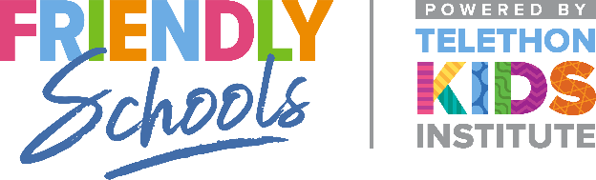

Newsletter Item 18
Aim: To provide families with strategies to help them to keep their children safer when online

How can I help my child stay safe online?
Young people usually don’t discuss with adults social problems they experience online, for fear they will have their access to the internet or mobile phone taken away from them. Therefore, it is recommended that each family establish a ‘Family Agreement’ for use of the Internet and mobile phones.
When negotiating a family agreement, the most important consideration is that it works for your family.
Having an effective family agreement is about building a positive relationship with your child. It ensures that technology can be enjoyed in a safe and mutually acceptable manner. Young people understand that they are responsible for their behaviour online. As such, the agreement should include consequences for unsafe or unacceptable use of technology (example agreements can be found on the Beacon app – Scan the QR code below with your camera app to access)
Discuss with your child what they think are reasonable consequences if the agreement is broken. The most effective agreements are those where mutual decisions are made in negotiation with your child. Whilst it is important to discuss all technologies with your children, the final agreement needs to be clear, simple, concise and manageable, and should be reviewed regularly.

