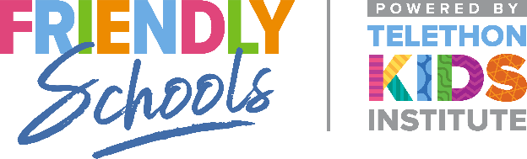

Newsletter Item 10
Aim: To provide strategies for families to effectively support their children if they are being bullied at school

Helping your children respond to bullying
Bullying involves more than the students who are bullied and those who bully others. Bullying often continues because people who are involved do not talk about it and seek help. This includes people who observe bullying – the bystanders. A bystander is someone who sees the bullying or knows that it is happening to someone else.

Helpful family responses include:
• Encouraging your children to discuss the situation
• Being aware of your own responses and reacting in a calm, helpful and supportive manner
• Believing your children – it is important that your children feels confident talking to you about problems
• Telling your children that bullying is wrong and reminding them that they have the right to feel safe and happy
• Making sure your children know how to get help and support at school
• Helping your children to make friends (having at least one good friend has been shown to reduce the likelihood and impact of bullying)
• Talking to your children’s teacher
• Asking your children what they would like you to do

