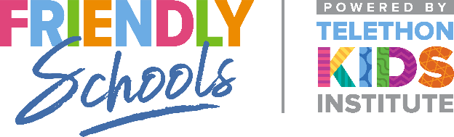

Newsletter Item 1
Aim: To introduce your school’s goals and actions for creating a friendly/supportive school
____________________________________________

Goals for our supportive school culture
Schools are increasingly recognising the need to address bullying, resilience, and social skills. Social and emotional learning begins at birth and is first experienced in the family home. Our school will be taking further steps this year to create a friendly and supportive culture. Since 1999, the Friendly Schools research team has conducted 23 high quality community-based studies with over 40,000 Australian children and adolescents, their families and school staff. The resource materials aim to help schools to encourage positive social behaviour and reduce bullying behaviour.
As parents you are the first teachers of your child’s social skills and first providers of emotional support. Social and emotional learning includes self-awareness skills, relationship skills, self-management skills, social decision-making skills, and social awareness skills. Actions we take will include [schools insert the actions they are planning to take for example: a review of our school bullying policy, introduction of activities to prevent or reduce bullying, strategies to help students cope with bullying and the development of social skills and resiliency factors.
Our goals are to: [these can be modified by the school to suit the actions they are taking]
• Provide all students with opportunities to develop and practise getting along with other children through classroom learning activities
• Create a positive social environment within our school which actively discourages bullying including cyber bullying
• Modify the school grounds and adult supervision ratios to discourage bullying
• Continue to encourage staff, students and parents to treat all school community members with respect, care and compassion
• Implement a clear and consistent approach to managing reported bullying incidents
• Provide parents with resources and strategies to help them communicate more effectively with their children about bullying

